**Create an IBM Cloud Account and Watson Project**

Create an IBM Cloud account to use the IBM Watson Studio service.

Visit [**cloud.ibm.com**](https://cloud.ibm.com/) and click on the "Create an IBM account" button.

If you have an IBM Cloud account already, sign in.

If you do not have an account, sign up.

Once you finish signing up, wait a few minutes to receive your IBM Cloud account confirmation email. Then return to [**cloud.ibm.com**](https://cloud.ibm.com/) and sign in.

**Register for IBM Watson Studio**

Click on the menu icon on the top left and select "Watson." Or just click [**here**](https://cloud.ibm.com/developer/watson/dashboard).

<https://dataplatform.cloud.ibm.com/home?context=wdp>

Scroll down and select "Try Watson Studio."

Next, select "Create Project."

Hover over "Data Science" and click "Create Project"

Enter a name for your project and click "Create" on the bottom right.

**Launch IBM Cluster and Notebook**

Click "Add to project" on the top and select "Notebook"

Enter a name for your notebook and select "Default Spark Python 3.5 XS" under runtime and click "Create Notebook" on the bottom right.

**Start Coding!**

Now you can run Spark code for your project in this notebook, which IBM will run on your cluster. In the next page, you'll find starter code to create a Spark session and read your uploaded dataset for the DSND Capstone project.

**Starter Code**

Below, you'll generate starter code to create a Spark session and read in the dataset for the DSND Capstone Project, Sparkify. First, download the dataset "medium_sparkify_event_data.json" attached at the bottom of this page in the classroom. Then, click on the Data icon on the top right of your IBM notebook and upload your file.

**[[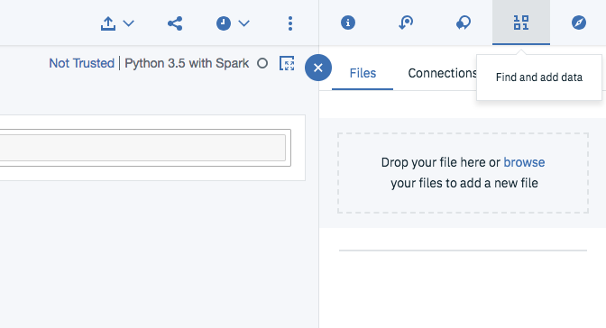](https://classroom.udacity.com/nanodegrees/nd025-ent/parts/577ca1f8-ed5e-4bbd-ab90-5934a870934e/modules/c30157ac-5572-435e-baed-722532e94333/lessons/ddbf749e-6536-4081-bf9f-9c20e59aee8c/concepts/373ea389-9540-42dc-916d-fcaa63359d53)](https://classroom.udacity.com/nanodegrees/nd025-ent/parts/577ca1f8-ed5e-4bbd-ab90-5934a870934e/modules/c30157ac-5572-435e-baed-722532e94333/lessons/ddbf749e-6536-4081-bf9f-9c20e59aee8c/concepts/373ea389-9540-42dc-916d-fcaa63359d53)**

Select the arrow next to "Insert to code" and select "Insert SparkSession DataFrame." This will generate code in the first cell of your notebook.

**[[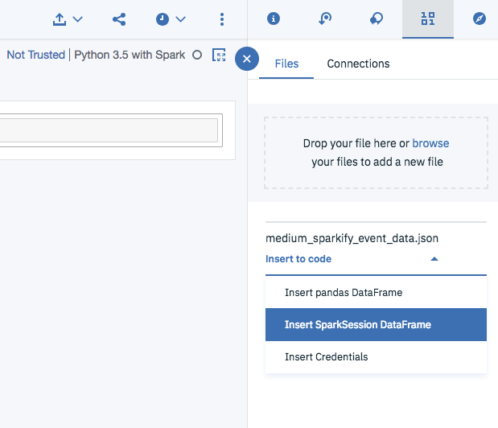](https://classroom.udacity.com/nanodegrees/nd025-ent/parts/577ca1f8-ed5e-4bbd-ab90-5934a870934e/modules/c30157ac-5572-435e-baed-722532e94333/lessons/ddbf749e-6536-4081-bf9f-9c20e59aee8c/concepts/373ea389-9540-42dc-916d-fcaa63359d53)](https://classroom.udacity.com/nanodegrees/nd025-ent/parts/577ca1f8-ed5e-4bbd-ab90-5934a870934e/modules/c30157ac-5572-435e-baed-722532e94333/lessons/ddbf749e-6536-4081-bf9f-9c20e59aee8c/concepts/373ea389-9540-42dc-916d-fcaa63359d53)**

Comment out the last two lines of the code generated, and run this cell to read in your data!

**[[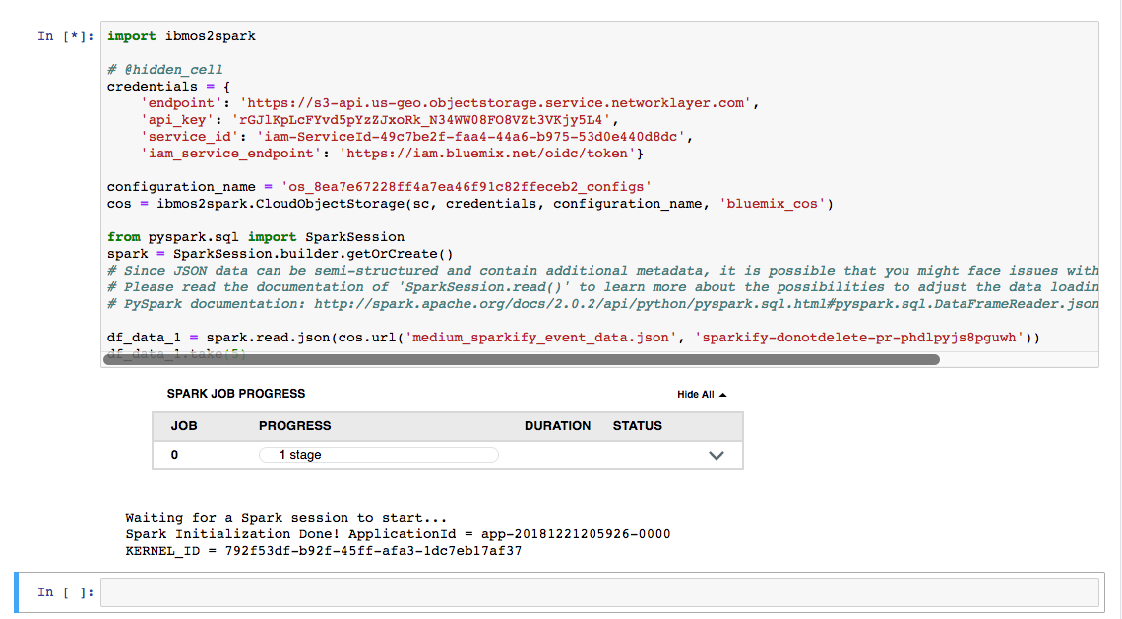](https://classroom.udacity.com/nanodegrees/nd025-ent/parts/577ca1f8-ed5e-4bbd-ab90-5934a870934e/modules/c30157ac-5572-435e-baed-722532e94333/lessons/ddbf749e-6536-4081-bf9f-9c20e59aee8c/concepts/373ea389-9540-42dc-916d-fcaa63359d53)](https://classroom.udacity.com/nanodegrees/nd025-ent/parts/577ca1f8-ed5e-4bbd-ab90-5934a870934e/modules/c30157ac-5572-435e-baed-722532e94333/lessons/ddbf749e-6536-4081-bf9f-9c20e59aee8c/concepts/373ea389-9540-42dc-916d-fcaa63359d53)**

You're ready to get started building your model on IBM Cloud!

**Avoid Paying Unexpected Costs**

Remember to delete your notebook and data files once you are finished with your project.

To do this, first click on the "Assets" tab on the top of your project page.

**[[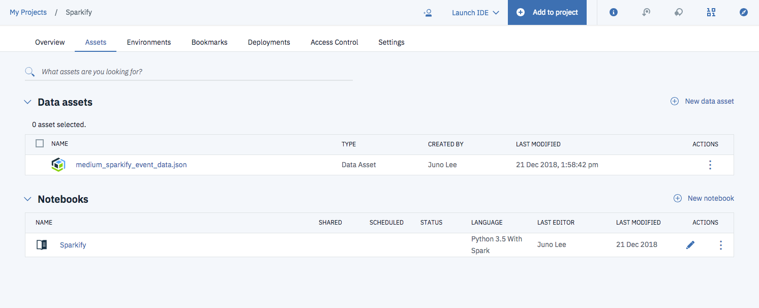](https://classroom.udacity.com/nanodegrees/nd025-ent/parts/577ca1f8-ed5e-4bbd-ab90-5934a870934e/modules/c30157ac-5572-435e-baed-722532e94333/lessons/ddbf749e-6536-4081-bf9f-9c20e59aee8c/concepts/f11bf426-57f9-4b66-a9c5-10dee0156cea)](https://classroom.udacity.com/nanodegrees/nd025-ent/parts/577ca1f8-ed5e-4bbd-ab90-5934a870934e/modules/c30157ac-5572-435e-baed-722532e94333/lessons/ddbf749e-6536-4081-bf9f-9c20e59aee8c/concepts/f11bf426-57f9-4b66-a9c5-10dee0156cea)**

Click on the three dots on the right of both the notebook and data file and select "Remove"

**[[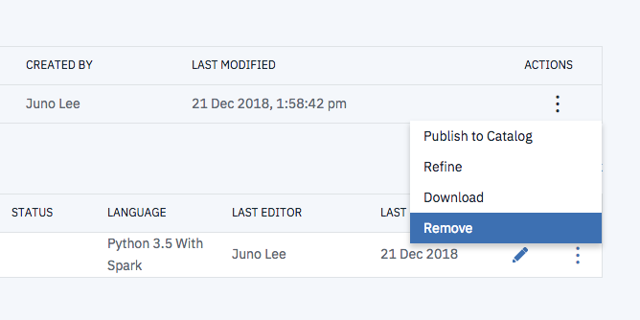](https://classroom.udacity.com/nanodegrees/nd025-ent/parts/577ca1f8-ed5e-4bbd-ab90-5934a870934e/modules/c30157ac-5572-435e-baed-722532e94333/lessons/ddbf749e-6536-4081-bf9f-9c20e59aee8c/concepts/f11bf426-57f9-4b66-a9c5-10dee0156cea)](https://classroom.udacity.com/nanodegrees/nd025-ent/parts/577ca1f8-ed5e-4bbd-ab90-5934a870934e/modules/c30157ac-5572-435e-baed-722532e94333/lessons/ddbf749e-6536-4081-bf9f-9c20e59aee8c/concepts/f11bf426-57f9-4b66-a9c5-10dee0156cea)**

Select "Manage" and then "Billing and usage" in your menu bar at anytime for information on billing.

**[[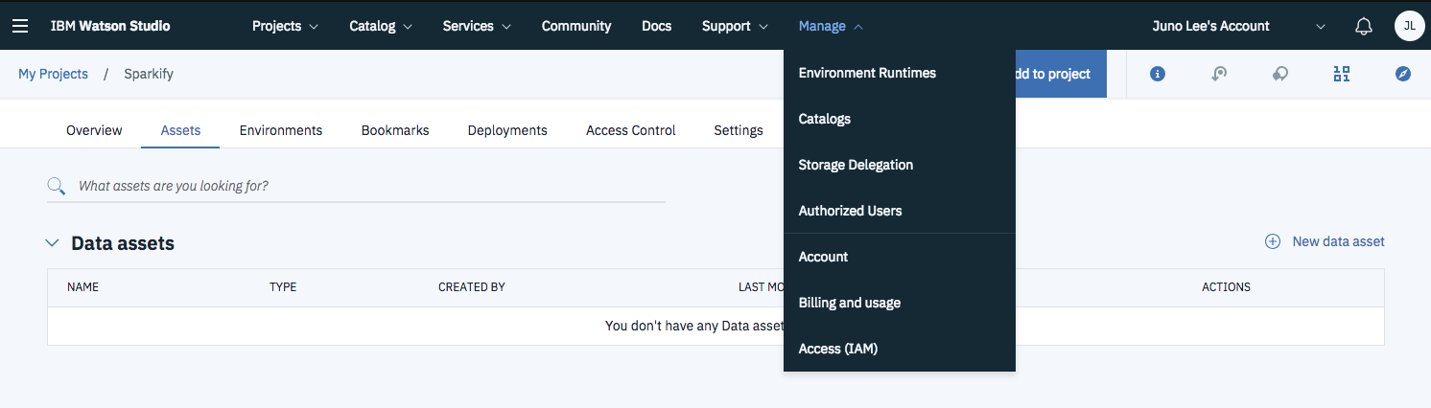](https://classroom.udacity.com/nanodegrees/nd025-ent/parts/577ca1f8-ed5e-4bbd-ab90-5934a870934e/modules/c30157ac-5572-435e-baed-722532e94333/lessons/ddbf749e-6536-4081-bf9f-9c20e59aee8c/concepts/f11bf426-57f9-4b66-a9c5-10dee0156cea)](https://classroom.udacity.com/nanodegrees/nd025-ent/parts/577ca1f8-ed5e-4bbd-ab90-5934a870934e/modules/c30157ac-5572-435e-baed-722532e94333/lessons/ddbf749e-6536-4081-bf9f-9c20e59aee8c/concepts/f11bf426-57f9-4b66-a9c5-10dee0156cea)**

Your account type should be "Lite" by default, and you should not be charged anything. You can confirm that your account type is "Lite" on the top right corner of the Usage page (make sure you are on the "Usage" section on the menu on the right).

**[[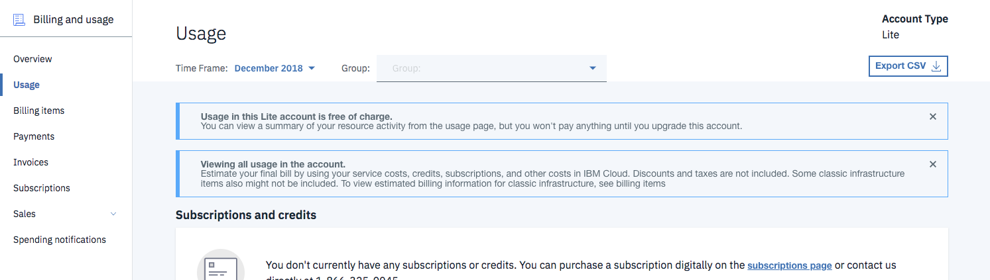](https://classroom.udacity.com/nanodegrees/nd025-ent/parts/577ca1f8-ed5e-4bbd-ab90-5934a870934e/modules/c30157ac-5572-435e-baed-722532e94333/lessons/ddbf749e-6536-4081-bf9f-9c20e59aee8c/concepts/f11bf426-57f9-4b66-a9c5-10dee0156cea)](https://classroom.udacity.com/nanodegrees/nd025-ent/parts/577ca1f8-ed5e-4bbd-ab90-5934a870934e/modules/c30157ac-5572-435e-baed-722532e94333/lessons/ddbf749e-6536-4081-bf9f-9c20e59aee8c/concepts/f11bf426-57f9-4b66-a9c5-10dee0156cea)**